EXPLORING THE FORESTS
Unit Test

NAME ____________________________________________ DATE _______________

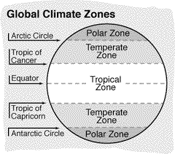

1. Name two temperature zones where most forests grow (2 pts.)

a. ______________________________ b. ______________________________

2. Why do most forests grow in these temperature zones? (4 pts.)

________________________________________________________________________

________________________________________________________________________

________________________________________________________________________

________________________________________________________________________

3. The temperature zones that have the most forests also have areas where no forests grow. Why do you think forests don't grow in these areas? (4 pts.)

________________________________________________________________________

________________________________________________________________________

________________________________________________________________________

________________________________________________________________________

4. How can you tell whether a forest is deciduous or coniferous? (4 pts.)

________________________________________________________________________

________________________________________________________________________

________________________________________________________________________

________________________________________________________________________

5. Match each label with the forest layer labeled A, B, C, D in the illustration. (4 pts.)

_______ shrub layer

_______ herb layer

_______ canopy layer

_______ understory layer

6. A food chain shows how one living thing provides energy for another. The beginning of all food chains is the sun. Draw a food chain. Include THREE living things that live in the forest community. Add labels. (5 pts.)

6. Suppose something in your food chain is destroyed. Tell what its loss might mean to other living things in the forest. (4 pts.)

7. Which type of forest has the greatest variety of living things? Why might this be?
(4 pts.)

________________________________________________________________________

________________________________________________________________________

________________________________________________________________________

________________________________________________________________________

