LESSON 1: Weather: Up Close and Personal
Name _____________ Date ______

- Using these pictures as a guide, circle the weather term that best identifies today’s sky condition. What do you observe?

 Sunny

 Cloudy

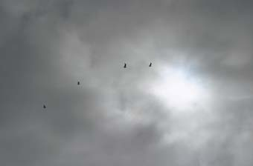 Overcast

- Using these pictures as a guide, choose the weather term that best indentifies today’s approximate air temperature. Use your skin as a “thermometer.”

 Warm

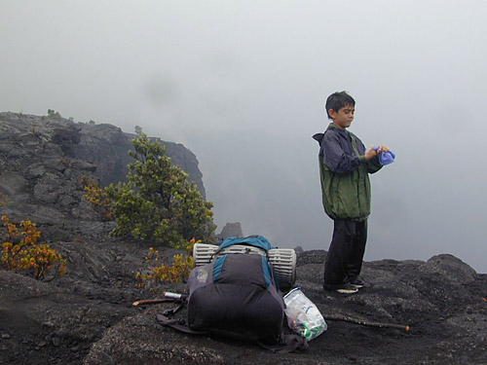 Cool
 Cold
- Is today’s weather rainy?

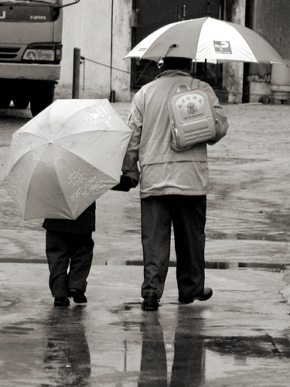 Yes or No?

- Is today’s weather snowy?

 Yes or No?

- Is today’s weather fair?

 Yes or No?
6. Is it windy today?

 Yes or No?

- Can you HEAR anything in our outdoor environment that may relate to the weather? (Write your answer next to the picture of the ear)
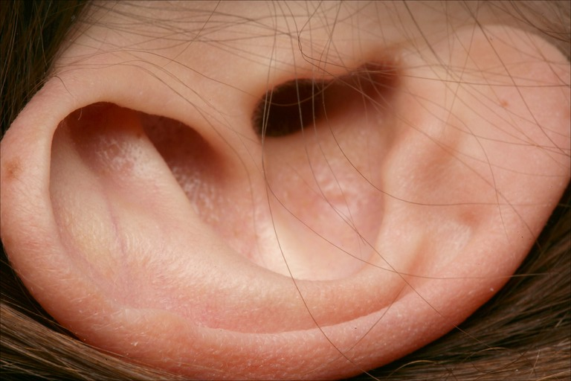

- Can you SMELL anything in our outdoor environment that could relate to the weather? (Write your answer next to the picture of the nose)

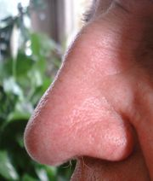

- Can you TASTE anything in our outdoor environment that could relate to our weather? (Write your answer next to the picture of “Mr. Taster”)



- Can you TOUCH anything in our outdoor environment that could relate to the weather? (Write your answer next to the picture of the hand)

