Mark A. Hauck
SCE 595 82
Spring 06

FINAL UNIT PLAN:
Weather

SEQUENCE OF INSTRUCTION:

LESSON 1: Wx unit introduction. Direct observation of present outdoor wx conditions. Comparisons of day to day wx patterns and identification of basic wx characteristics.

LESSON 2: Identification of the four season and observation of earth’s position on its axis in relation to the sun as a factor to predict wx conditions.

LESSON 3: Measurement using the Fahrenheit scale and applied to observing characteristics of salt water when heat and cold variables introduced.

LESSON 4: Observation of changes in matter when heat is applied. Results are graphed.

LESSON 5: Wx unit conclusion. Identification of wx map symbols and predicting movements of wx fronts.

*********************************************************************

Lesson 1

OUR WEATHER: UP CLOSE AND PERSONAL

1. GRADE LEVEL: 3-4

2. OBJECTIVE: The students will identify characteristics of present outdoor weather conditions via direct observation, utilizing their five senses where applicable. They will also identify basic weather terms and use them to clarify their observations. The observations will be conducted over a two day period so comparisons can be made and possible changes in weather noted.

3. PROCEDURE:

- Opening Activity—The instructor will make the classroom as dark as possible by turning of the room lights and drawing the window shades. The objective here is to obscure as much of the view of the outdoors as possible. The students are asked to close their eyes and describe from memory any characteristics of that day’s weather. The instructor will record these observations on the blackboard. After about 5 minutes of memory observations, the students can open their eyes and the window shades are opened. The lights are turned on as well. The students and the instructor check their observations to check their accuracy. The instructor will also show the students the accuweather.com and/or weather.com websites and check what trained weather scientists have observed about the day’s weather in their area. The instructor will refer to their science textbook which explains some basic weather terms used in this lesson: clouds, sun, rain, snow, wind, and temperature.
- Day 1--The instructor leads the students outdoors to conduct some direct observations of the present weather conditions. The students are instructed to use their five senses (sight, hearing, smell, touch, taste) and record on their worksheets (see attached) what they observe.
- Day 2—The activity is repeated exactly as Day 1 and another worksheet is completed.
- At the end of day 2’s observations, the students will compare these with Day 1’s observations and note any differences on the backs of the worksheets.

4. MATERIALS:

- Science textbooks with a chapter on weather
- Worksheets
- Computer w/ internet connection
- LCD projector and screen

5. ASSESSMENT:

- The following questions will be asked by the instructor as a follow-up. The students will answer them on the back of their Day 2 worksheet: 1) Did you observe any changes in the weather conditions from Day 1 to Day 2? 2) Identify any changes in weather conditions, if any. 3) Which of the five senses were most used in observing weather conditions? 4) Which of the five senses were least used? 5) Which of the five senses do you think trained weather scientists use to observe the weather?
- The student will turn in their completed worksheets for evaluation

Lesson 2

THE FOUR SEASONS AND WEATHER

1. GRADE LEVEL: 3-4

- OBJECTIVE: The students will observe, using a classroom simulation, the position of the sun throughout the year and identify the earth cycle of four seasons (winter, spring, summer, and fall). The students will infer how the position of the sun and the cycle of the seasons affect the weather.

- PROCEDURE:
a. Opening Activity: The instructor asks for two volunteers. One student will play “the earth” and hold a globe that is able to freely spin on an axis held by a sturdy frame. The other student will play “the sun” and hold a bright flashlight. First, it needs to be reviewed that the earth rotates once on its axis in a 24 hour period and rotates one time around the sun every 365 ¼ days. The instructor then explains how the earth tilts either away or toward the sun, depending on the season of the year. The teacher reviews the names of the four seasons and explains the dates when they officially occur on our calendar. A bright red paper star is affixed to globe where the USA is located, to give the students around the room a visible point of reference. The room lights are dimmed and the flashlight is turned on. The first season demonstrated is winter where the northern hemisphere is tilted away at its maximum point. This is December 21st, the first day of winter, or the winter solstice, in the USA. The student holds the globe in place while the instructor spins the globe slowly and explains that the sun’s rays are at their lowest in the sky, which is one of the reasons for low amount of heat hitting the northern hemisphere. The other is the shorter daylight period. Days are shorter because of the extreme tilt. The student gradually tilts the globe so the equator is perpendicular to the “sun.” This is 3/21, the vernal equinox. The sun is a bit higher in the sky and the northern hemisphere is getting warmer from the more direct rays. The days are also getting longer. This demonstration repeats for the summer solstice, autumnal equinox, and finally, back again to the winter solstice. The aspect that this is a cycle in nature must be reinforced!. It should be explained that during the summer solstice in the northern hemisphere, that our friends in South America are experiencing their winter solstice. To complete this simulation, the instructor should take the globe and perform an actual “rotation” around “the sun” (with the flashlight being trained on it) while simulating the gradual tilting motion occurring throughout the year.

b. The students return to their own tables and are given small flashlights and some small plastic figurines, like army men, that are able to stand on their own. With masking tape and markers, they are asked to mark the directions of north, south, east and west in a compass-like circle on the table top. After they have done this, they will be asked to use their flashlight and simulate the rising and setting of the sun. They are asked to check their notes to be reminded the position of the sun in the sky during each of the four seasons that have been discussed, primarily on the dates 12/21, 3/21, 6/21, and 9/21. With the “sun” rising in the east and setting in the west, each student will manipulate the flashlight and simulate the sun’s movement through the sky. The lights in the room should again be dimmed. They will point the flashlight at the plastic figurines and note the length of the shadows being cast. For the ease of the demonstration at this grade level, the position of the flashlight should be at an approx. 15 degree angle to the table for the winter solstice, an approx 45 degree angle for the equinoxes, and an approx 90 degree angle for the summer solstice. This is illustrated on their worksheet for this lesson. After each group has simulated the sun’s sky position through each of the four seasons, they must infer how this affects the weather.

- MATERIALS

a. adequately sized world globe for a class demonstration
b. one high powered flashlight
c. paper cut out of star
d. plastic army men
e. roll of masking tape
f. markers
g. small handheld flashlight, preferably self-charging
h. worksheets

5. ASSESSMENT

a. Students complete the questions on the worksheet and turn it in at the conclusion of the lesson. (see attached)

Lesson 3

MR, FAHRENHEIT’S THERMOMETER

1. GRADE LEVEL: 3-4

2. OBJECTIVE: Students will identify the Fahrenheit scale and use it to observe changes in temperature in weather simulations conducted by the students. Heat and cold variables will be introduced to help students make predictions about how temperature changes in sea water can affect weather.

3. PROCEDURE:

a. Opening activity-- The instructor appears in the front of the class and introduces himself as Mr. Fahrenheit. Mr. Fahrenheit would like to show the class his new invention, a thermometer. His thermometer measures temperature, which is an essential part of observing and predicting weather, with a scale known as the Fahrenheit scale. As a visual aid, the instructor has created a mock up of a thermometer using a large piece of white poster board. On the front of the poster board, the face of a thermometer is drawn. Two slits are cut at the bottom and the top of the thermometer. A piece of white ribbon is partially colored red to simulate the liquid inside the thermometer and inserted through the slits to allow it to be slid up and down. Using the thermometer mock-up, Mr. Fahrenheit explains where would be the freezing point and the boiling point of water. He also explains the general range of temperatures in their surroundings throughout the year. The instructor asks the students to infer what the temperature might be today, after having completed Lesson 1 during a recent class. A visit to the websites accuweather.com and weather.com confirms what that day’s actual outside temperature may be. Before the students begin their hands-on activity, the teacher explains that temperature affects weather and changes the states of matter in the environment. It is explained that the cooling and heating of the earth’s oceans affect weather. They are asked what’s different about sea water than tap water (salt).

b. Day 1--The students are given beakers full of salt water (with a few drops of blue food coloring added) and a lab thermometer. It is salt water to simulate sea water They are asked to record the temperature of the “sea” water at room temperature on their worksheets. Then, they will place CRUSHED ice (made with tap water dyed with red food coloring) into the beaker. For the next ten minutes, they will record the temperature of the water as it cools from the added crushed ice and then slowly rises back toward room temperature as the crushed ice melts. This is to simulate wintry conditions. After the ten minute period is concluded, the students remove the thermometers and will carry their beakers over to small heat lamps (set up and monitored by the instructor), which will simulate exposure to the sun’s heat. Re-immerse the thermometer into the water and observe any temperature changes for each minute up to another ten minutes. The temperature readings will be recorded on their worksheets. The final step would be to turn off the heat lamps, to simulate a setting sun/night time environment. Immediately, each group of students place a sheet of saran wrap over their beaker of water so it seals the mouth tightly. The beaker is then allowed to remain on a front table away for their desk areas where they can be left unattended and safe from being interfered with until the next day. The students are asked to predict what will happen to the water in the beakers overnight and record those predictions on their worksheets. Will the water cool? What else will happen to the water?

c. Day 2—The students observe the state of the water inside the beakers and record their final observations on their worksheets. Ideally, condensation should have formed on the underside of the saran wrap, which simulates water vapor, which forms clouds.

4. MATERIALS:

a. glass beakers
b. lab thermometers
c. food coloring
d. water source
e. worksheets
f. science textbooks
g. crushed ice
h. box of table salt

5. ASSESSMENT:

a. The students will complete the worksheet questions and answer these final follow-up questions on Day 2: 1) What happened to water inside the beaker overnight? 2) How does heat and cold affect salt water? 3) How does fresh water affect the saltiness of the sea water?

Lesson 4

HOW DOES THE TEMPERATURE OF A
SOLID AFFECT ITS MELTING TIME?

1. GRADE LEVEL: 3-4

2. OBJECTIVE: Students will observe and graph the rate of time required to liquefy (or melt) equal sized pieces of chocolate of different temperatures.

3. PROCEDURE:

a. Opening Activity: The teacher stands in front of the class and announces that instead of having lunch today, he is going to have a big sized chocolate bar instead. The teacher needs to grip the chocolate bar tightly as he relates a humorous anecdote about how he loves chocolate and when he was a kid, he wished everything tasted like chocolate. He also tells the class that his mother used to get angry with them because he'd get chocolate stains all over his clothes. It was because he would take too long to eat the chocolate and it would melt in his hand too quickly. This storytelling's purpose is to give enough time for the chocolate bar to begin visibly melting in his hand. By the end of the part about chocolate stains, the teacher should be able to hold up his hand and show that the chocolate bar has already begun to melt into a liquid. He says that if only he had figured out a way to keep the chocolate from melting so quickly, he would not have gotten into trouble with his mother. The teacher hypothesizes that if perhaps the chocolate was kept at a certain temperature, it wouldn't melt into a liquid so quickly.

b. The students are split into groups of three. Each group member will test three pieces of chocolate from three different trays. Each chocolate piece must be of equal size and weight. One tray has been kept in the freezer. One tray has been kept in the refrigerator. The third tray has been kept at room temperature. When one student is sampling the chocolate, the others in the group will be recording the time it takes for the chocolate to begin to liquefy (or melt) in their hand. All students in each group should sample from each tray consecutively, so enough time elapses between samplings to allow the skin temperature to return to normal. (Note: please be sure to identify any students with food allergies in regard to this activity)

c. The students will first predict from which tray the chocolate will melt more quickly and most slowly. These predictions will be recorded in their notebooks.

d. The teacher should inform the groups of the following variables: freezer, refrigerator, room, and hand surface temperatures, to be included on their graph’s x scale.

4. MATERIALS:

a. chocolate bars
b. access to refrigerator and freezer
c. food serving trays, large enough to accommodate the amount of chocolate needed for all students.
d. graph paper
e. notebooks and pencils
f. stop watches

5. ASSESSMENT:

a. Students will graph their results and include this graph in their submitted portfolio. They will also answer this question and include their answer on the graph sheet:

i. "The chocolate stored at ____ degrees F is the best to prevent it from liquefying too quickly while being held in your hand."

Lesson 5

WATER EVAPORATION

1. GRADE LEVEL: 3-4

2. OBJECTIVE: The students will observe the evaporation of water with the aid of different external heat sources. They will graph the results of each heat source to verify each source's ability to evaporate water. The students also will observe the evaporation of water over a period of 72 hours and make predictions as to the outcomes of this long-term exposure of water to the atmosphere in the classroom.

PROCEDURE:

a. Opening Activity: The teacher asks the students to walk over to the windows in the classroom and place their mouths within a few inches of the window glass. The teacher asks them to breathe on the window glass until they see moisture collecting. When they stop, they are asked to observe what happens next. The teacher asks the students if they know what happened to the moisture that suddenly disappeared from the window glass. The teacher explains that the liquid water appearing on the windows had evaporated and turned into a gas. The gas from their breath had heated the window glass briefly, causing the present water vapor in the air to condense onto the glass. When the hot gas from the breath stopped, the liquid water collecting on the glass surface returned to its gaseous state.

b. The students are broken up into groups and are assigned an area of the blackboard. (Note: a classroom with a blackboard is necessary to make this activity work) They are given a small desk lamp and a hair dryer that they can easily plug in to an outlet strip. The teacher, carrying a small pail of water and a sponge, will evenly swipe an area of the blackboard in front of each group. One student will immediately point the activated desk lamp about 6 inches away from the dampened blackboard area. This step will be repeated three times, with a person in each group assigned to time the exact moment the lamp was applied to the area until the exact moment the area is completely dry. The group will record each time and compute an average based on the three samplings.

c. The entire process is repeated using a hair dryer pointed about 6 inches away from the dampened blackboard area. (Note: as with using any electrical devices, ensure that the students exercise extreme caution when using these devices. If possible, target particularly trustworthy and well-behaved students to be the designated electrical device "holder."

d. The students will then start the second part of the experiment which will conclude on the following Monday (this is presuming that this unit has been conducted since Monday). This allows a suitable amount of time for a quantity of water to evaporate. The students are given a petri dish and a 30 mL beaker. Each will be filled with exactly 15 mL of water and left on the classroom window sill over the weekend. Food coloring drops should be placed in each container. The students are asked to predict which container will have the least amount of water remaining. On Monday, the amount of water in each container will be measured. This data will be recorded in the students' notebooks. The result should show that the petri dish is either completely dry or containing the least amount of water. If dry, some food-coloring residue should remain.

4. MATERIALS

a. desk lamps
b. hair dryers
c. extension cords
d. multi-outlet strips
e. bucket
f. sponge
g. water source
h. petri dishes
i. 30 mL beakers
j. food coloring
k. graph paper
l. notebooks and pencils
m. blackboard
n. classroom windows
o. stop watches

5. ASSESSMENT

a. The students complete their graphs charting the results of the desk lamp and hair dryer experiment.

b. They will answer the following questions:

i. Which heat source was the most efficient at turning water into a gas?

ii. Which container in the part 2 experiment had the least amount of water?

iii. Infer why that container had the least amount of water (if any) remaining compared to the other.

iv. Was there any non-water residue in the container identified in question ii? Infer why this happened

THIS IS THE END OF THE UNIT. ALL STUDENTS WILL BE ASKED TO COMPILE ALL NOTES, GRAPHS, ILLUSTRATIONS, AND ANSWER SHEETS AND SUBMIT THEM IN A FOLDER FOR EVALUATION.

WORKSHEETS AND ASSESSMENTS ON NEXT PAGES …….

Weather: Up Close and Personal Worksheet
Name _____________ Date ______

- Using these pictures as a guide, circle the weather term that best describes today’s sky conditions.

 Sunny

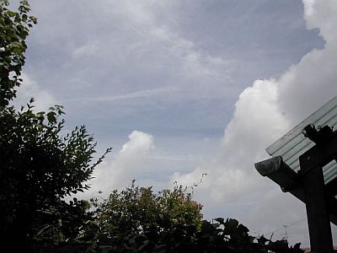 Cloudy

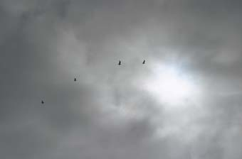 Overcast

- Using these pictures as a guide, choose the weather term that best describes today’s air temperature.

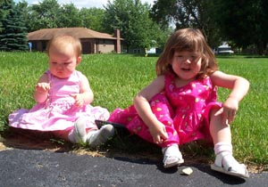 Warm

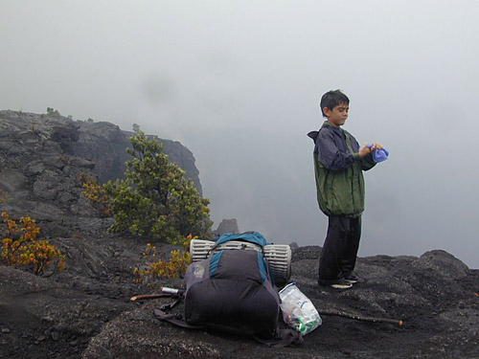 Cool

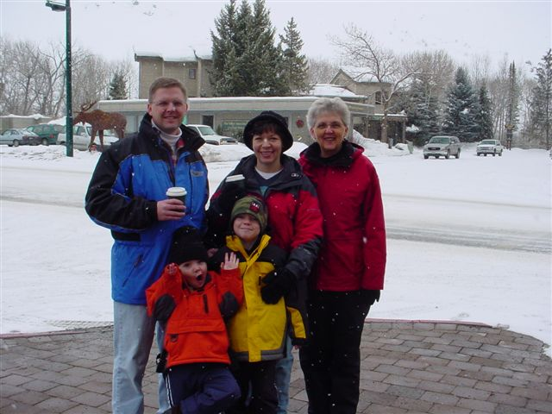 Cold
- Is today’s weather rainy?

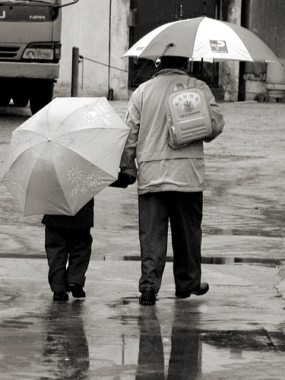 Yes or No?

- Is today’s weather snowy?

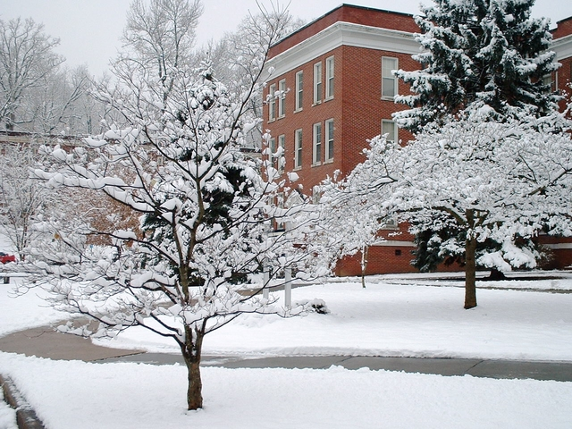 Yes or No?

- Is today’s weather fair?

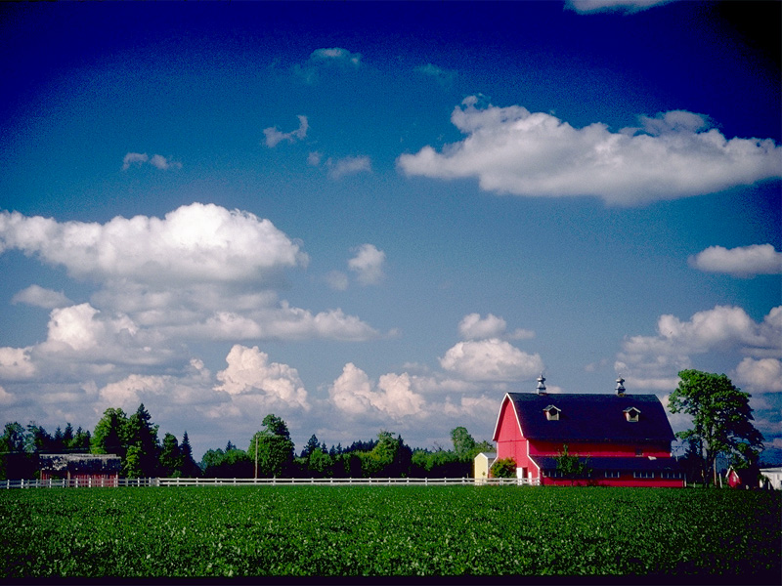 Yes or No?
6. Is it windy today?

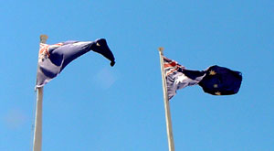 Yes or No?

- Can you HEAR anything in our outdoor environment that may relate to the weather? (Write your answer next to the picture of the ear)
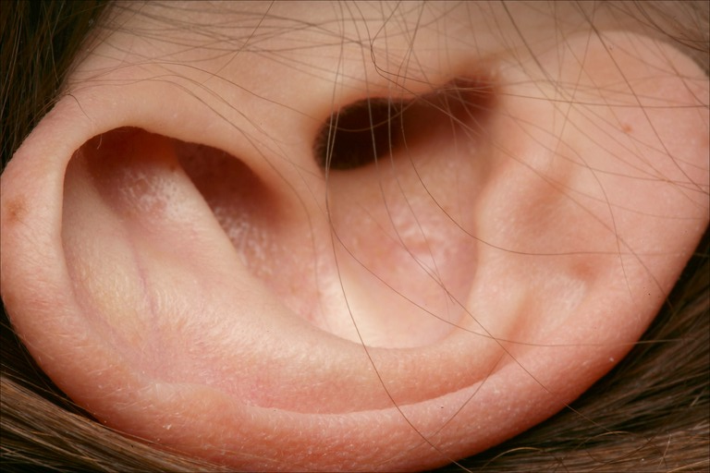

- Can you SMELL anything in our outdoor environment that could relate to the weather? (Write your answer next to the picture of the nose)

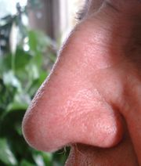

- Can you TASTE anything in our outdoor environment that could relate to our weather? (Write your answer next to the picture of “Mr. Taster”)

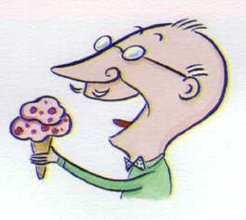

- Can you TOUCH anything in our outdoor environment that could relate to the weather? (Write your answer next to the picture of the hand)

