Weather: Up Close and Personal Worksheet
Name _____________ Date ______

- Using these pictures as a guide, circle the weather term that best describes today’s sky conditions.

 Sunny

 Cloudy

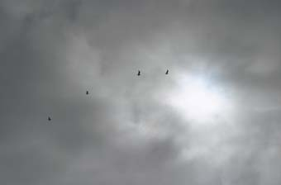 Overcast

- Using these pictures as a guide, choose the weather term that best describes today’s air temperature.

 Warm

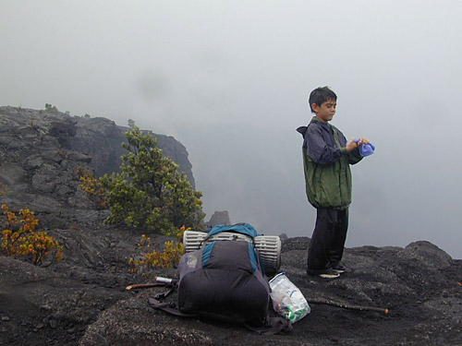 Cool

 Cold
- Is today’s weather rainy?

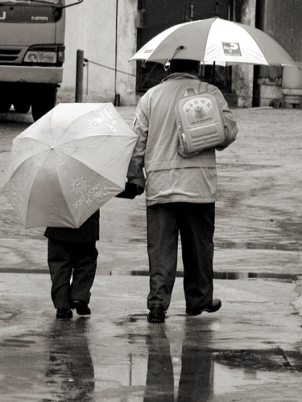 Yes or No?

- Is today’s weather snowy?

 Yes or No?

- Is today’s weather fair?

 Yes or No?
6. Is it windy today?

 Yes or No?

- Can you HEAR anything in our outdoor environment that may relate to the weather? (Write your answer next to the picture of the ear)
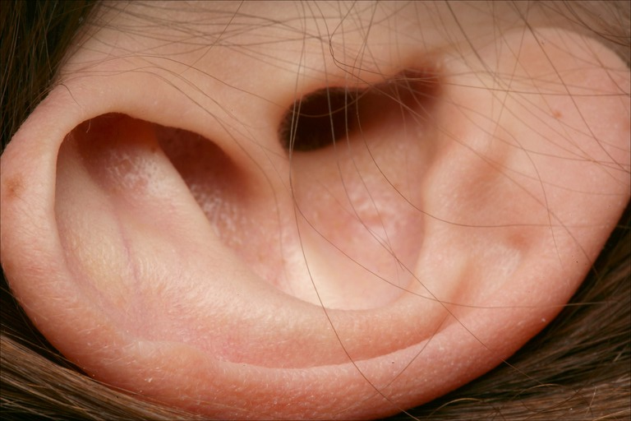

- Can you SMELL anything in our outdoor environment that could relate to the weather? (Write your answer next to the picture of the nose)

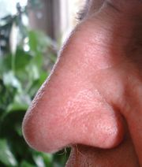

- Can you TASTE anything in our outdoor environment that could relate to our weather? (Write your answer next to the picture of “Mr. Taster”)



- Can you TOUCH anything in our outdoor environment that could relate to the weather? (Write your answer next to the picture of the hand)

