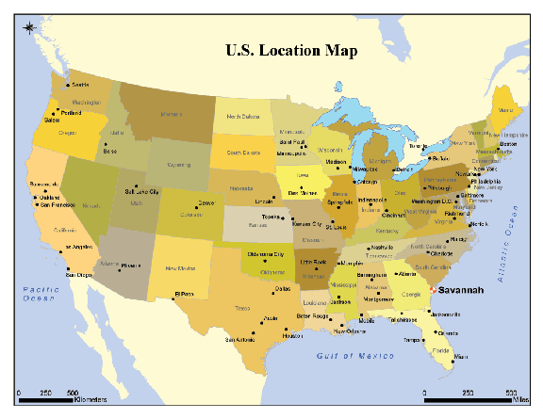

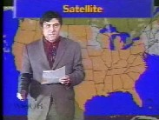

DAY ___

1. Identify our hometown with a red dot sticker.

2. Identify which state is the center of the HIGH pressure system?

3. Identify which state is the center of the LOW pressure system?
4. Identify the states currently affected by the COLD front.

5. Identify the states currently affected by the WARM front.

6. Identify any changes in the positions of the weather fronts compared to the previous day. Identify the direction they moved in.

7. Predict the weather in our hometown, based on the information given on the map. (You may continue eon back of sheet)

Lesson 5:
“Let’s Play Weatherman”

